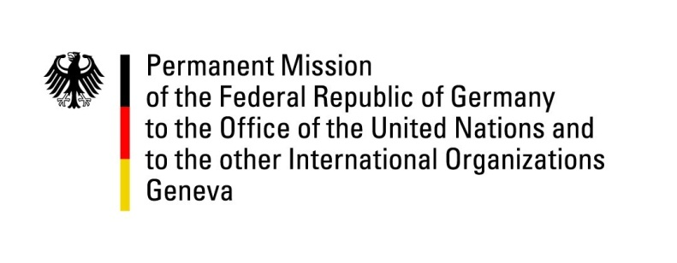

United Nations Human Rights Council
27th Session of the UPR Working Group

Geneva, 2 May 2017

---
German
National Statement
Tunisia

Mr. President,
Germany congratulates Tunisia on the adoption of its Constitution protecting human rights and following the principles of separation of powers.
Yet, Germany is concerned about the implementation of the constitutional safeguards for all and, therefore, recommends:
- Strengthen the independence of the national mechanism for the prevention of torture and other forms of ill-treatment including by the provision of a separate and adequate budget.
- Eliminate all forms of discrimination against women, including by reforming the personal status code to grant equal rights to inheritance to women and by repealing the circular from 1973 to allow women to marry non-Muslim spouses.
- Amend the penal code to explicitly criminalize marital rape, to abolish provisions allowing a perpetrator of sexual violence to escape prosecution by marrying the victim (Penal Code Article 227bis).
- Modify or repeal Article 230 of the Penal Code in order to decriminalize same-sex relations of consenting adults.

Thank you.

Advance questions Germany
UPR Tunisia

What are the reasons for the decision of the Government of Tunisia not to implement Germany’s recommendation to abolish the death penalty in its Constitution, but on the contrary to broaden the legal basis for its promulgation?

What specific measures has the Government of Tunisia taken to fight cultures of impunity and to end torture and other forms of ill-treatment as well as arbitrary, cruel, inhumane or degrading treatment or punishment?

What are the specific plans of the Government of Tunisia to bring the reform of its legal provisions on associations in line with international human rights law and in what way will the revised law differ from the existing decree law no. 88 dating from 2011?

