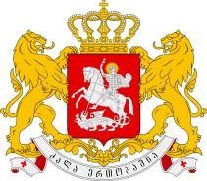
GEORGIA

Statement by Mr. Temuri Pipia,
First Secretary of the Permanent Mission
The 27th Session of the UPR Working Group
UPR of Tunisia

Geneva, 2 May 2017

We warmly welcome the Delegation of Tunisia and thank the Head of Delegation for the presentation.

We welcome the submission of the mid-term report by Tunisia in 2014 regarding the results achieved in implementing recommendations accepted during its second UPR and further encourage the Government to follow this practice.

Georgia welcomes the establishment of various institutional mechanisms on human rights. We highlight efforts aimed at strengthening national legislative framework, including adoption of the Constitution in 2014 and encourage the Government of Tunisia to further mainstream human rights issues at all levels.

Georgia would like to recommend to the Government of Tunisia:

- To consider the ratification of the Optional Protocol to the Convention on the Rights of the Child on a communications procedure;
- To intensify efforts to bring domestic legislation in line with international standards to combat all forms of violence and discrimination against women and girls;

We wish the delegation of Tunisia a successful UPR.

