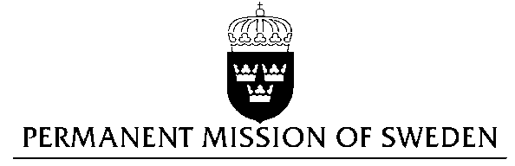
UN Human Rights Council

UPR 27th session

Statement by Sweden in the interactive dialogue on Poland
(1 min 25 sec)

Mr President,

Sweden wishes to welcome the delegation of Poland.

Sweden recommends the Government of Poland:

- To implement the recommendations issued by the Venice Commission and the European Commission with regard to the Rule of Law.

- To take decisive steps to decrease political control over state owned media and to ensure independence of private as well as state owned media.

- To take steps to ensure the acceptance and the general public knowledge of the existing law on anti-discrimination and to take steps to increase the practical use of the law.

- To ensure that women are provided the necessary medical and professional service to exercise their legal right to termination of pregnancy, and to ascertain that women have the right to decide over their own bodies.

- To take steps to ensure the acceptance and the general public knowledge of the existing measures for the legal protection of children, in particular with regard to children with disabilities.

We recognize that poverty levels have decreased in Poland in the recent period, helped by a new child benefit program to reduce poverty among children and their families, together with increased minimum salaries, and a programme to promote affordable housing.

I thank you Mr. President

