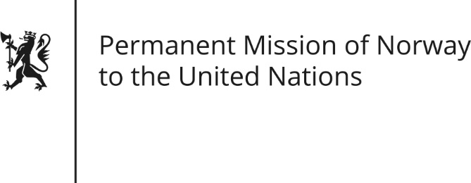

STATEMENT by Ms Kristin Hefre

Universal Periodic Review 27th Session. Review of Poland

9 May 2017

Check against delivery

Norway thanks the Polish delegation for presenting its national report.

We recognize that efforts are being made to fight discrimination. However, Norway recommends that the penal code is amended, to provide that crimes motivated by discrimination on any grounds, including disability, gender identity and expression and sexual orientation, are included in the code and therefore can be investigated and prosecuted as hate crimes. We also recommend that the Human Rights Commissioner’s office is provided with sufficient financing to fulfill its obligations.

An independent civil society is an important part of democratic societies. Norway recommends that Poland ensures a legal and financial framework that allows NGOs to operate.

Regarding the sexual and reproductive rights for women, Norway recommends that Poland ensures that women can access lawful abortion by creating clear, legally binding regulations for the implementation of the 1993 Family Planning Act.

