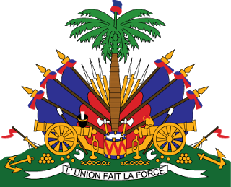
Declaration of Haiti

27th Session of the Working Group

Universal Periodic Review

Poland

9 May 2017

The Haitian delegation warmly welcomes the delegation of the Republic of Poland to its third UPR working group and we thank the Polish authorities for their oral presentation.
The Haitian delegation welcomes the success of Poland’s policies and programs in regards to improving women's rights, reducing poverty levels, ratification of the CRPD, and combatting human trafficking.
Haiti would like to make two recommendations:
1/ Review and reform the Prosecution Office with a view clearly separating the function of Minister of Justice and Prosecutor General, in full consultation with key stakeholders ;
2/ As a follow-up to recommendations 90.45, 90.46, 90.47, 90.48, 90.49, 90.57 and 90.60 from the second cycle, reinstate the Council for the Prevention of Racial Discrimination, Xenophobia and Related Intolerance, with a view of also addressing racism in sport to demonstrate the authorities seriousness in combatting such prejudices, in full consultation with key stakeholders.
Haiti wishes the Polish government and her people success in implementation during this third cycle.
I thank you.

