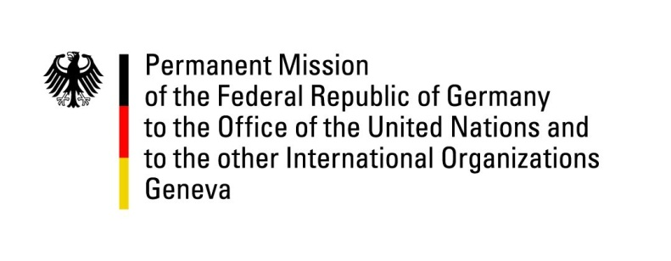

United Nations Human Rights Council
27th Session of the UPR Working Group

Geneva, 9 May 2016

---
German recommendations and advance questions
to
Poland

Thank you, Mr. President,

Germany welcomes Poland’s accession to several international human rights Conventions.

Germany remains concerned about controversial legislation regarding the justice system as well as the media and offers the following recommendations:
- Protect the independence of the judiciary. Respect the opinions of the Venice Commission, the OSCE Office for Democratic Institutions and Human Rights and the EU Commission, especially regarding justice reform. Ensure that the independence of the Constitutional Tribunal and of judicial institutions is maintained;
- Guarantee freedom and independence of the media. Ensure that rules regarding media ownership comply with EU law (no discrimination, no retroactive legislation);
- Ensure that regulations pertaining to the right to privacy are in line with the principles of legality, necessity and proportionality. Establish an independent and effective oversight mechanism.

I thank you, Mr. President.

GERMAN ADVANCE QUESTIONS TO POLAND
- In the context of recent legislative changes, including reforms of the Constitutional Tribunal Act and the Law on Prosecution: What measures is Poland taking to ensure compliance with the rule of law and the independence of the judiciary in line with European and international standards, i.a. Poland’s obligations under the ICCPR?

- The Polish legislation on abortion and access to contraception is one of the most restrictive in Europe. How is Poland planning to reduce the number of potentially life-threatening, clandestine abortions if access to modern contraception is not always guaranteed and legal access to safe abortion is often not available?

