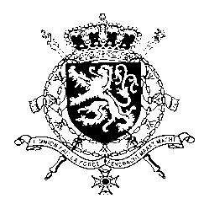
Représentation permanente de la Belgique auprès des Nations Unies et auprès des institutions spécialisées à Genève

WG UPR – Poland
Belgian intervention
9th of May 2017

Mr. President,

Belgium welcomes the delegation of Poland and wishes it every success in the exercise of its third Universal Periodic Review.

We acknowledge that several positive steps were taken by Poland with respect to the implementation of the recommendations accepted during its second UPR. However, some recommendations accepted by Poland in the previous UPR were not implemented and on certain issues there is still room for progress.

In this regard, Belgium wishes to formulate the following recommendations:

R1. To amend the Criminal Code to provide that crimes motivated by discrimination on grounds, grounds of sexual orientation or gender identity are investigated and prosecuted as hate crimes.

R2. To strengthen the elimination of all forms of violence against women by criminalizing domestic violence and marital rape.

R3. To implement the recommendations of the Human Rights Committee regarding the full independence and impartiality of the judiciary.

Finally, we would like to draw Poland’s attention to concerns raised within the International Holocaust Remembrance Alliance regarding a draft law concerning the memory of the Holocaust.

Thank you, Mr. President

