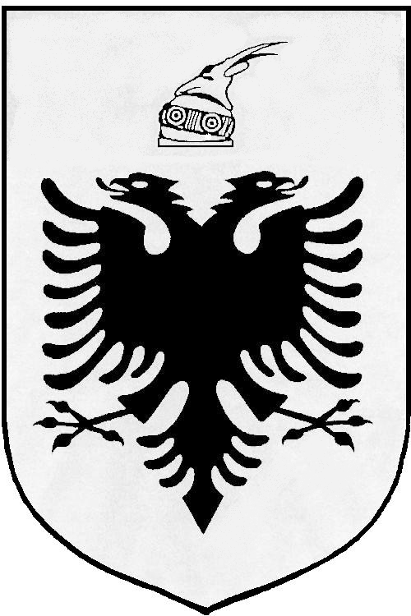
MISIONI I PËRHERSHËM I  REPUBLIKËS SË SHQIPËRISË  GJENEVË | PERMANENT MISSION OF  THE REPUBLIC OF ALBANIA  GENEVA

Universal Periodic Review

27th
Session

(1 – 12 MAY 2017)

Albania Intervention on the Third Cycle of the UPR of Poland

Geneva, 9 May 2017

-Check against delivery-

Mr. President,

Albania would like to welcome and congratulate the Polish delegation on presenting their Report under the third cycle of UPR, today before the Human Rights Council.

It is remarkable the solid foundation of legal and institutional framework of human rights protection and promotion in Poland. We commend the continuing commitment of Poland aiming to put in place an effective cooperation mechanism within the public administration at the central and regional levels with respect to the principle of equal treatment.

While inviting the Government of Poland to further strengthening its national efforts and human rights mechanisms, Albania would like to make the following recommendations:

- To ratify the International Convention for the Protection of All Persons from Enforced Disappearance and the International Convention on the Protection of the Rights of All Migrant Workers and Members of Their Families.

- To consider either reinstating the Council for the Prevention of Racial Discrimination, Xenophobia and Related Intolerance, or establishing an alternative multi-stakeholder institution with the objective of preventing discrimination and intolerance.

In conclusion, Albania would like to wish to the delegation of Poland, a very successful review.

Thank you!

