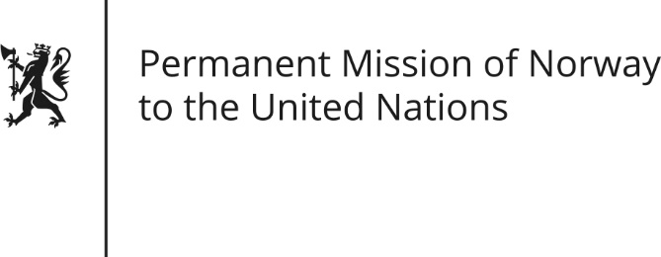

STATEMENT by Permanent Representative Hans Brattskar

Universal Periodic Review 27th Session. Review of the Philippines

8 May 2017

Check against delivery

We welcome the delegation of the Philippines and the presentation of the national report.

Norway appreciates the efforts and commitment by the Philippine Government to work for peace.

We also commend recent efforts to strengthen workers’ rights and conditions and to combat corruption. We encourage you to continue these reforms.

Norway recommends efforts to be taken to eliminate extrajudicial killings and enforced disappearances, and to intensify efforts to carry out the prosecution of such crimes.

Norway further recommends the Philippine Government and lawmakers to respect its obligations under the Second Optional Protocol to the ICCPR and to refrain from the plans to reimpose the death penalty.

Finally, Norway recommends necessary measures to be taken to provide adequate protection to journalists and human rights defenders.

