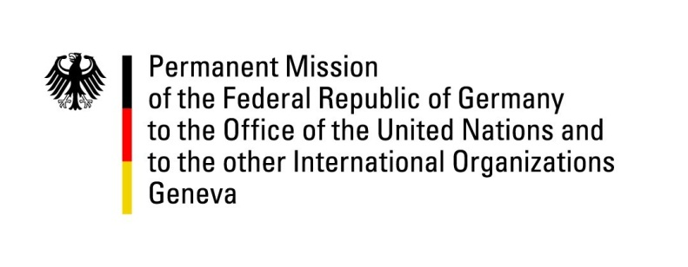

United Nations Human Rights Council

27th Session of the UPR Working Group

Geneva, 8 May 2017

German questions and recommendations to
The Philippines

Thank you, Mr. President,

Germany welcomes the Philippines’ efforts to address various insurgencies by striving for inclusive peace processes.

Germany remains deeply concerned about reports of human rights violations in the context of the so called “war on drugs”. We would like to offer the following recommendations:
- Take all necessary measures to prevent extrajudicial killings and enforced disappearances and carry out impartial investigations to hold perpetrators accountable;
- extend an invitation to the UN Special Rapporteur on extrajudicial, summary or arbitrary executions for an official visit to the country in line with UN terms of reference without any further delay;
- refrain from lowering the age of criminal responsibility in line with commitments under the Convention of the Rights of the Child;
- take all necessary measures to protect the life of human rights defenders, journalists and other threatened persons.

I thank you, Mr. President.

GERMAN ADVANCE QUESTIONS TO THE PHILIPPINES
- In the context of the fight against illegal drugs more than 7000 extrajudicial killings have been reported since June 2016. What concrete measures are the Philippines taking to ensure the effective prevention and prompt investigation of all extrajudicial killings as well as the prosecution of alleged perpetrators?
When will the Philippines start to continuously and publicly provide statistics with data from credible sources on killings and investigations?
How many investigations of these extrajudicial killings have already been launched and how many have led to a formal prosecution and sanctions?

- Also in consequence to the fight against illegal drugs, the conditions in detention facilities have worsened and their maximum occupancy often has been exceeded substantially. What measures is the government taking to ensure humane conditions in prisons and to provide medical services to drug-addicted detainees?

Will the Philippines consider replacing pretrial detention with non-custodial measures in line with the 2016 UNCAT recommendations?

- The Philippines are discussing to reinstate the death penalty, which would constitute a breach of its commitments under the second Optional Protocol to the ICCPR. Will the Philippines reconsider the reinstatement of the death penalty?

- The Philippine Congress is currently discussing a bill aiming to lower the age of criminal responsibility to 9 years, which would be a direct breach of the Convention on the Rights of the Child. Will the Philippines reconsider the lowering of the age of criminal responsibility?

- Even though the Philippines have adopted an act on enforced or involuntary disappearance (Republic Act No. 10353 of 2012), this issue remains a concern, as the law is not applied to crimes of continuance committed before 2012. What concrete measures is the government taking to effectively implement this national law and to ensure the impartial investigation and prosecution of enforced disappearances?

