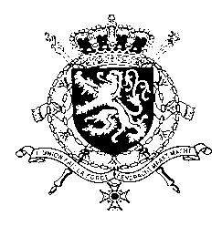
Représentation permanente de la Belgique auprès des Nations Unies et auprès des institutions spécialisées à Genève

WG UPR 27 – Philippines
Intervention of Belgium
8th of May 2017

Mr. President,
Belgium welcomes the delegation of the Philippines and commends the Government on creating a Monitoring, Reporting and Response System for children affected by conflict as well as signing a Memorandum of Agreement further defining the roles and responsibilities of Government agencies in monitoring and responding to grave violations against children.)
In this regard, we recommend:
R1. To ensure that victims of grave violations receive timely, effective and appropriate services through the Monitoring, Reporting and Response System for children affected by conflict.
Regarding the rights of the child, we further recommend:
R2. To maintain the age of criminal responsibility for children as it currently stands.
Finally, as a member of the Group of Friends of the Second Optional Protocol, Belgium is concerned about intentions to reintroduce the death penalty, despite the fact that the Philippines are a State Party to the Second Optional Protocol. Therefore, we recommend:
R3. To respect its obligations under international law as a State Party to the Second Optional Protocol to the International Covenant on Civil and Political Rights, aiming at the abolition of the death penalty.
I thank you, Mr. President

