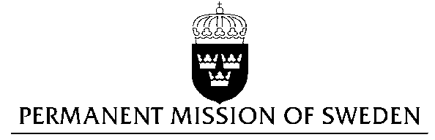
UN Human Rights Council

UPR 27th session

Statement by Sweden in the interactive dialogue on the Netherlands

(1 min 15 sec)

Mr President,

Sweden wishes to welcome the delegation of the Netherlands.

Sweden recommends the Government of the Netherlands:

- To issue a national action plan for countering discrimination as well as hate crimes, including indicators for success.

- To introduce additional measures to reduce the use of detention of individuals solely for immigration purposes and consider using other alternatives when possible.

The Netherlands has been criticized for trying to deport rejected asylum seekers to areas in Somalia controlled by al-Shabab – contrary to the UNHCR guidelines. The Netherlands has also been asked to only use detention of asylum seekers as a last resort.

Individuals with “non-western” background, women, and LGBTI-persons experience most discrimination in the Dutch labor market.

Women still get paid less than men for the same work, and face job discrimination due to pregnancy and motherhood.

Women have also been denied employment for wearing headscarf.

The unemployment rate is significantly higher among Dutch citizens with “non-western” backgrounds.

Many LGBTI-persons in the Netherlands encounter hate crimes but very few cases results in prosecution and, or, conviction of the offender.

I thank you Mr. President

