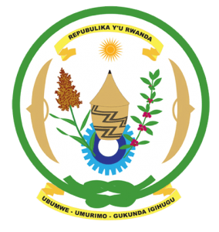
27th Session of the Universal Periodic Review Working Group
Review of the Kingdom of the Netherlands
10th May 2017
Statement by Rwanda delivered by Mr. Moses Rugema
Thank you Mr. Vice President,
- Rwanda warmly welcomes the delegation of the Kingdom of the Netherlands and thanks them for the presentation of their national report.
- We welcome the positive steps that have been taken by the Netherlands since its last UPR including ratification of the CRPD and measures and policies to combat discrimination. We welcome the update by the delegation on actions to address racial profiling. Combating racial discrimination however requires proactive measures and we encourage the Netherlands to enhance its efforts in that regard.
- We have one question to the delegation, as part of its efforts to combat discrimination, has the Netherlands undertaken an assessment or analysis of potential risk factors for atrocity crimes in the Netherlands with a view to their prevention?
We recommend that the Netherlands:
- Consider including in its next UPR report, information on measures it has taken to analyse potential risk factors of atrocity crimes including through utilising the UN Framework of Analysis for Atrocity Crimes and any assistance it has given to other States to prevent atrocity crimes.

We wish the Netherlands every success in the implementation of the recommendations of this UPR. Thank you

