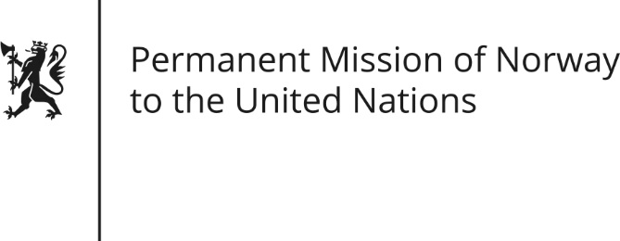

STATEMENT by Mr Paul Bjordal

Universal Periodic Review 27th Session. Review of the Netherlands

10 May 2017

Check against delivery

Norway welcomes the steps taken by the Netherlands since its last UPR, including making full use of the Netherlands Institute for Human Rights to promote, protect and monitor the national human rights situation.

In line with the 2013 report from the European Commission against Racism and Intolerance (ECRI), as well as the 2016 stocktaking by ECRI, Norway recommends that the Netherlands consider making racist motivation a specific aggravating circumstance in sentencing.

