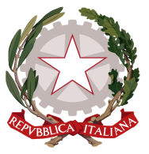
Permanent Mission of Italy to the
International Organizations in Geneva
Check against delivery
UPR – Netherlands
10 May 2017
Delivered by Mr. Massimo Baldassarre, First Secretary

Thank you, Mr. President.

We welcome the distinguished members of the Dutch delegation and thank them for their national report and today’s presentation.

Italy welcomes Netherlands’s commitment to the UPR and its continuous attention to human rights as well as all achieved results in this field. We particularly commend the ratification of CRPD and the adoption of relevant measures for its implementation, the active involvement of municipalities in the promotion and protection of human rights, the National Action Programme to combat discrimination in all its forms, the new Youth Act which involve young people and families in framing youth policy and youth participation as well as all the actions carried out in addressing asylum seekers, groups in vulnerable situations and migrants needs.
Following the steps taken since its last UPR, Italy encourages Netherlands to continue its efforts in promoting and protecting human rights and we would like to recommend Netherlands to:

- Consider signing and ratifying the Optional Protocol to the Convention on the Rights of Persons with Disabilities.

We wish Netherlands a successful UPR.
I thank you.

