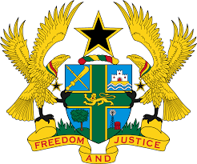

HUMAN RIGHTS COUNCIL - 27TH SESSION OF THE UPR WORKING GROUP
(1ST – 12TH MAY, 2017)

REPORT OF THE WORKING GROUP ON THE UNIVERSAL
PERIODIC REVIEW OF THE NETHERLANDS

STATEMENT BY GHANA DELIVERED BY MR. ALEXANDER GRANT NTRAKWA, DEPUTY PERMANENT REPRESENTATIVE, ON WEDNESDAY 10TH MAY, 2017

Thank you Mr. President.

Ghana warmly welcomes the delegation of the Kingdom of the Netherlands to the third cycle of the UPR. My delegation lauds the progress made by the Netherlands since its last UPR to promote and protect human rights and fundamental freedoms, notably the publication of The Netherlands’ National Action Plan on Human Rights in 2013 and ratification of the Convention on the Rights of Persons with Disabilities in 2016.

Ghana notes with concern the disappearance in a large scale of unaccompanied children who might have become victims of human trafficking in the Netherlands. We urge the Netherlands to take steps to investigate the disappearance of unaccompanied children from asylum reception centres and to search for and identify those children who might have been the victims of enforced disappearance.

Ghana further recommends the following for consideration by the Netherlands:

1. Ratify the International Convention on the Protection of the Rights of All Migrant Workers and Members of their Families;

2. Ratify the Optional Protocol to the Convention on the Rights of Persons with Disabilities; and

3. Ratify the Optional Protocol to the Convention on the Rights of the Child on a communications procedure.

Finally, Ghana wishes the Netherlands success with the UPR outcome.

I thank you.

