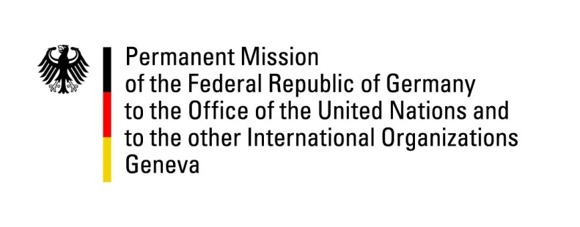

United Nations Human Rights Council
27th Session of the UPR Working Group

Geneva, 10 May 2017
---
German recommendations
to the
Netherlands

Mr. President,

Germany welcomes the delegation of the Netherlands to the UPR and commends the government for its commitment to upholding human rights and its commitment to advocate human rights and fundamental freedoms in its bilateral and multilateral relations.

The government has however not yet signed and ratified The Optional Protocol to the CRC on a Communications Procedure (OP3 CRC).

Germany would like to submit the following recommendations:

- Ratify as soon as possible the third optional protocol to the Convention on the Rights of the Child (CRC);
- Extend the National Action Plan on Human Rights to cover all relevant human rights issues, including counter-terrorism, government surveillance, migration and human rights education.

Thank you, Mr. President.

Question submitted in advance by Germany:

- What concrete steps has the government of the Netherlands taken to fulfill the state’s obligation to provide human rights education to all students by including it in the mandatory core curriculum of both primary and secondary schools, as well as in teacher training courses?

