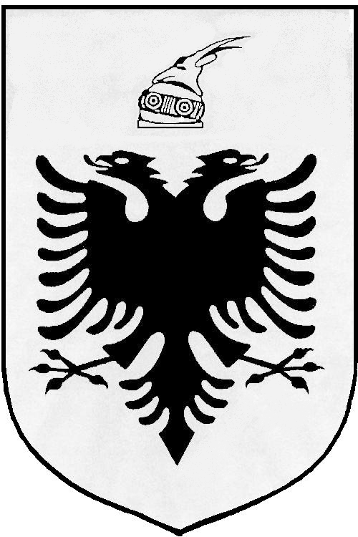
MISIONI I PËRHERSHËM I  REPUBLIKËS SË SHQIPËRISË  GJENEVË | PERMANENT MISSION OF  THE REPUBLIC OF ALBANIA  GENEVA

Universal Periodic Review

27th
Session

(1 – 10 MAY 2017)

Albania Intervention on the Third Cycle of the UPR of The Netherlands

Geneva, 10 May 2017

-Check against delivery-

Mr. President,

Albania would like to welcome and congratulate the delegation of The Netherlands on presenting their Report under the third cycle of UPR, today before the Human Rights Council.

It is remarkable the continuing effort of the Netherland to make sure that the four democratic countries of the Kingdom of the Netherlands are governed by the rule of law.
We commend the constitutional reforms undertaken by the Netherlands with a focus on poverty reduction, economic development, advancement of children’s rights and good governance.

While inviting the Government of The Netherlands to further strengthening its national efforts and human rights mechanisms, Albania would like to make the following recommendations:

- To consider withdrawing its reservations to articles 26, 37 (c) and 40 of the Convention on the Rights of the Child.

- To take effective measures towards giving end to discrimination on grounds of racial or ethnic origin, skin colour, socioeconomic status, gender, religion and other status in the field of employment and education.

In conclusion, Albania would like to wish to the delegation of The Netherlands, a very successful review.

Thank you!

