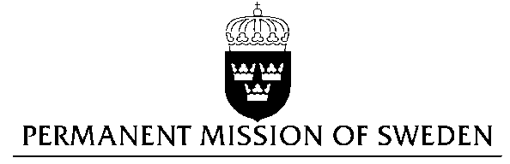
UN Human Rights Council

UPR 27th session

Statement by Sweden in the interactive dialogue on Morocco

Delivered by Minister-Counsellor Josefin Simonsson Brodén
Geneva, May 2, 2017 (speaking time 1 min 5 sec)

Mr President,

Sweden wishes to welcome the distinguished delegation and express our thanks for its presentation. Sweden would like to give the following recommendations to the Government of Morocco:

- to review all laws and practices that discriminate on the basis of gender and bring them in line with international law and standards and to take steps to further improve the protection of women who are subject to violence, including through amending the Penal Code to ensure the criminalization of marital rape,
- to take measures to counter-act the trend of judicial authorizations of marriages involving minors, including through necessary amendments of the Family Code,
- to ensure the Constitution's provisions on freedom of the press, freedom of opinion and expression and the freedom of assembly and association are respected, including for people who want to express their views on the situation of and in Western Sahara,
- to end the prosecution of journalists under the Penal Code for peacefully exercising their right to freedom of opinion and expression and for ensuring the right to information,
- to remove obstacles to non-governmental associations seeking registration from the authorities.
Sweden notes that violence against women, especially domestic violence, remains a widespread problem in Morocco. Although we welcome that the draft law 103.13 combating violence against women was adopted by Parliament in May 2017, it failed to define rape in line with international standards and to recognize marital rape. It also perpetuates negative gender stereotypes and does not address obstacles to accessing justice. Barriers to prosecuting violence against women include the requirement that a victim must show a medical certificate that the she suffered physical injuries resulting in more than 20 days of disability, in order to bring a criminal assault complaint.

Sweden notes positively that the 2011 Constitution stipulated the creation of an Authority for Gender Parity and Fighting All Forms of Discrimination. However, the implementing legislation has yet to be adopted. Moroccan women remain clearly underrepresented in politics and the labour market. Despite the 2004 revision of the Family Code that raised the legal age of marriage from 15 to 18 years, the number of under-age females getting married has doubled since then. This is partially due to the option for judges to make exemptions at the request of parents.

The National Dialogue on Civil Society, carried out 2012-2014, made recommendations to strengthen the freedom of association and assembly and capacity of civil society organisations, as well as securing the input of civil society on government policy. While Moroccan civil society is dynamic, most organizations are small and lack capacity. Sweden notes that several organisations face difficulties in obtaining official recognition in order to be able to carry out their activities legally, particularly those advocating for the self-determination of Western Sahara. Journalists and critics of the authorities continue to face prosecution under the Penal Code, and foreign journalists have in some cases been expelled.

Challenges related to freedom of the press and freedom of opinion and expression are particularly acute for individuals and organisations highlighting the situation in Western Sahara. The Penal Code allows the bringing of charges against individuals that challenge the Government of Morocco’s official position and claim to Western Sahara.

Thank you, Mr President.

