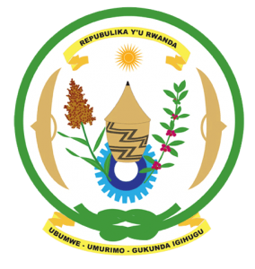
27th Session of the Universal Periodic Review Working Group
Review of the Kingdom of Morocco
02nd May 2017
Statement by Rwanda delivered by Mr. Moses Rugema
Thank you Mr. Vice President,
- Rwanda warmly welcomes the delegation of the Kingdom of Morocco and thanks them for the presentation of their national report.
- Rwanda welcomes Morocco’s commendable efforts to promote and protect human rights, promote the rule of law and consolidate the democratic process.
- Rwanda welcomes Morocco’s accession to the OPCAT and the Optional Protocol to the CEDAW.
- Rwanda further commends Morocco for the notable progress it has registered in improving the social and economic status of its citizens and in reforming the justice sector and improving access to justice.

Rwanda has the following recommendations. That Morocco:
- Consider withdrawing the remaining declarations and reservations to the CEDAW.
- Maintains its de facto moratorium on the use of the death penalty with a view towards its total abolition including through the ongoing process of reform of the penal code.
We wish Morocco every success in the implementation of the recommendations of this UPR. Thank you

