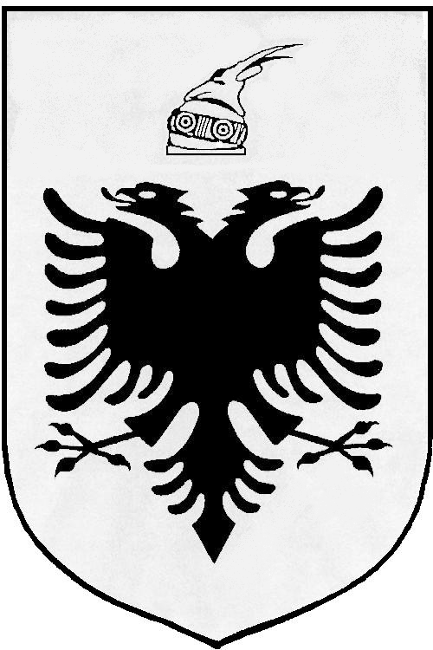
MISIONI I PËRHERSHËM I  REPUBLIKËS SË SHQIPËRISË  GJENEVË | PERMANENT MISSION OF  THE REPUBLIC OF ALBANIA  GENEVA

Universal Periodic Review

27th
Session

(1 – 12 May 2017)

Albania Intervention on the Third Cycle of the UPR of Kingdom of Morocco

Geneva, 2 May 2017

-Check against delivery-

Mr. President,

Albania would like to welcome and congratulate the delegation of Kingdom of Morocco on presenting their UPR Report today before the Human Rights Council.

It is remarkable the progress made in the domestic legal framework since the second universal periodic review of Morocco, in particular the establishment and consolidation of institutions provided for under the Constitution with a view to promote and protect the human rights and trade competition.

While encouraging the Government of Kingdom of Morocco to further strengthening its national efforts and human rights mechanisms, Albania would like to make the following recommendations:

- Revise the provisions of Criminal Code on terrorism with a view to define precisely terrorism-related offences and ensure the legislation to be in line with the CCPR.

- Continue the current national debate on the abolition of the death penalty and consider formalizing the de facto moratorium currently observed.

In conclusion, Albania would like to wish to the delegation of Kingdom of Morocco, a very successful review.

Thank you!

