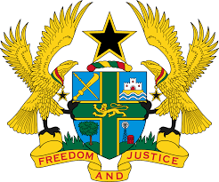

HUMAN RIGHTS COUNCIL - 27TH SESSION OF THE UPR WORKING GROUP
(1ST – 12TH MAY, 2017)

REPORT OF THE WORKING GROUP ON THE UNIVERSAL PERIODIC
REVIEW OF INDIA

STATEMENT BY GHANA DELIVERED BY MR. JOSEPH OWUSU-ANSAH, COUNSELLOR, ON THURSDAY 4TH MAY, 2017

Thank you Mr. President for giving me the floor.

Ghana extends a warm welcome to the delegation of India to the UPR mechanism. My delegation commends India for the progress so far made to promote equal access to justice for all, in particular the commitment to reduce backlog and delays in court proceedings, and to provide more legal aid to the poor and marginalized in the country.

Ghana is concerned that although India signed the UNCAT in 1997 and accepted during the first and second cycle of the UPR to ratify the instrument, action is yet to be taken by the Government. Ghana urges India to take steps to finalise ratification of the UNCAT and its Optional Protocol.

Ghana further calls upon India to enact the Rights of Persons with Disabilities Bill, 2014 and to include in it a specific section that protects women and girls with intellectual disabilities from forced sterilization.

My delegation wishes India well with the review process.

I thank you.

