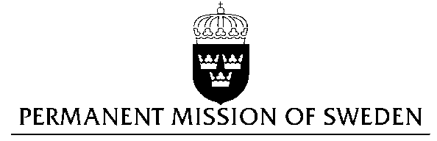
UN Human Rights Council

UPR 27th session

Statement by Sweden in the interactive dialogue on India

(1 min 05 sec)

Mr President,

Sweden wishes to welcome the delegation of India and thank it for its presentation.

Sweden recommends the Government of India:

- To ratify the Convention against Torture and Other Cruel, Inhuman or Degrading Treatment or Punishment (CAT).

- To criminalize marital rape.

- To ensure that any measure limiting freedom of expression, assembly and association on the internet, is based on clearly defined criteria in accordance with international law including international human rights law.

- To take concrete steps to prevent coercive, unsafe, and abusive sterilization and create greater accountability for these practices, including ensuring free and full consent prior to conducting the procedure and compliance with international and national standards.

Our recommendations are made on the basis of the following considerations:

India accepted the recommendation to ratify the Convention against Torture in the past UPR, but this recommendation still has to be implemented.

Marital rape is not yet criminalized in India – in spite of many calls for criminalization, including from the UN.

Internet is generally free in India, and the government is actively working to increase internet access through initiatives like Digital India. However, blocking of websites and network disruption occur in entire regions on the pretext of national security concerns.

India has one of the world’s highest rates of female sterilizations, about 37% of women, compared to 29% in China, according to the UN. About 4.6 million Indian women were sterilized in 2011 and 2012, according to the government of India.

We wish India all success in promoting an inclusive society where everyone’s rights are equally respected, regardless of caste, gender, sexual orientation, religion and belief.

I thank you Mr. President

