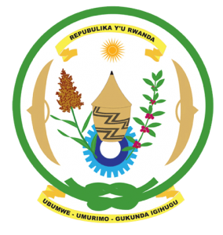
27th Session of the Universal Periodic Review Working Group
Review of India
04th May 2017
Statement by Rwanda delivered by Mr. Moses Rugema
Thank you Mr. Vice President,
- Rwanda warmly welcomes the delegation of India and thanks them for the presentation of their national report and the update just provided.
- Rwanda welcomes India’s commendable efforts to promote and protect human rights including through various legislative and policy measures.
- We further commend India for the notable progress it has registered in improving the social and economic status of its citizens by adopting an inclusive sustainable development approach.
- While noting the progress made in combating discrimination, we encourage India to enhance its efforts to combat racial discrimination and discriminatory practices against women.

Rwanda has the following recommendations. That India:
- Consider withdrawing the remaining declarations and reservations to the CEDAW.
- Consider imposing a de facto moratorium on the use of the death penalty with a view towards its total abolition.
We wish India every success in the implementation of the recommendations of this UPR.
Thank you

