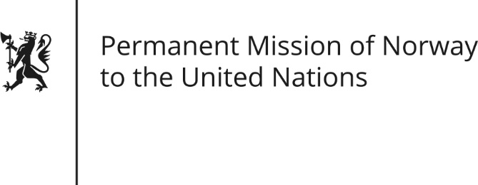

STATEMENT by Deputy Permanent Representative Kjersti Sommerset

Universal Periodic Review 27th Session. Review of India

4 May 2017

Check against delivery
Norway thanks India for its national report,

We commend India for fulfilling recommendations from UPR 2012 in amending the child labour act and ratifying ILO conventions 138 and 182.

Integrating gender equality and women’s empowerment is key in the follow up of the UPR. We recommend India to allocate adequate resources to realise the SDG targets to reduce maternal mortality and end preventable deaths of newborns and children under five.

Norway also recommends that India amend or revoke section 377 to de-criminalise same-sex relations.

UN Special Rapporteurs have stated the importance of allowing human rights defenders to work without undue limitations. Norway recommends a revision of the FCRA to ensure benign working conditions for civil society in India.

Finally, we recommend that India ratify the UN convention against torture urgently and in accordance with its commitments from UPR 2012.

