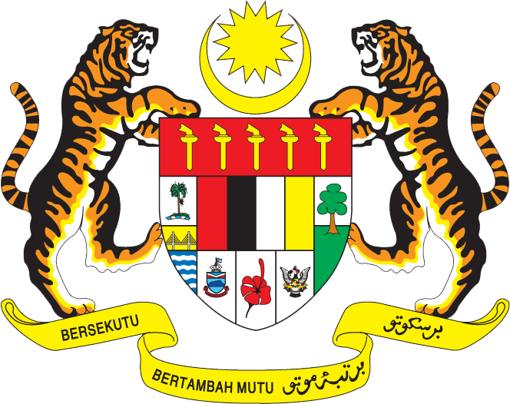

Statement by Ms. Syuhada Adnan,
Second Secretary,
Permanent Mission of Malaysia to the United Nations Office
27th Session of the UPR Working Group: Review of India
4 May 2017

Thank you Mr. President,

The Malaysian delegation welcomes His Excellency Mr. Mukul Rohatgi, Attorney-General of India and his delegation, and congratulates India for presenting its national report.

- Malaysia commends India for making wide-ranging progress in the promotion and protection of human rights in the country. The pragmatic, transparent and inclusive approach adopted by India towards implementing its human rights commitments has translated into advancements in good governance, provision of an improved standard of living for its citizens, and the cultivation of innovations and new partnerships in addressing its human rights challenges.

- Malaysia views positively various development programs to assist the citizens of India to pursue upward socioeconomic mobility such as the Stand-up India Scheme that provides opportunity through entrepreneurship. Malaysia also commends the implementation of the Aadhaar Unique Identification Number Scheme that has improved assistance delivery and has ensured that Government assistance and subsidies reaches the intended recipient.

- We wish India the best in its future undertakings for further progress in the field of human rights

I thank you, Mr. President.

GENEVA
4 May 2017

