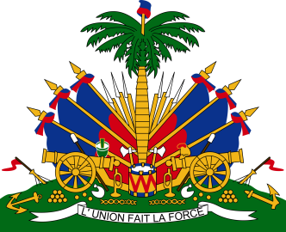
Declaration of Haiti

27th Session of the Working Group

Universal Periodic Review

Inde

4 May 2017

The Haitian delegation warmly welcomes the delegation of the Republic of India to its third review by the UPR working group and we thank them for their oral presentation.
The Haitian delegation takes note of the great focus on reducing poverty, especially extreme poverty, and increasing access to quality education.

Haiti wishes to make two recommendations:
1/ continue to study the possibility of a universal basic income as way to further reduce poverty levels with a view of possibly phasing out the existing social protection system, in full consultation with all stakeholders;
2/ establish a national action plan for combating hate crimes, racism and negative stereotypes against people of African descent inside its territory, including appropriate programmes of public awareness that will address the problem of racism and Afro-phobia, in full consultation with those particularly affected.

Haiti wishes the Indian government and her people success in implementation during this third cycle.

I thank you.

