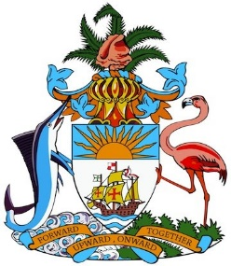

Statement by Ms. Sasha Dixon, Second Secretary
Permanent Mission of the Commonwealth of The Bahamas to the United Nations Office and Other International Organisations in Geneva
at the 27th Session of the Universal Periodic Review Working Group
Presentation of National Report by the Government of Ecuador
1 May, 2017
Geneva, Switzerland

Thank you, Mr. [Vice] President.

The Bahamas warmly welcomes the Ecuadorian delegation.

Ecuador has made significant strides in the field of human rights since its last Universal Periodic Review (UPR), despite challenges, such as recovery from the earthquake that struck the country exactly one year ago. Further, the inclusive approach taken in crafting the national report, and incorporation of supporting statistical data are commendable.

The Bahamas recommends that Ecuador:

- Continues to develop, implement, monitor and strengthen policies to reduce rates of obesity and the incidence of non-communicable diseases (NCDs);
- Increases access to quality education by indigenous and Afro-Ecuadorian women and those in rural areas; and
- Introduces targeted strategies and labour market reforms to promote women’s increased participation in formal sector employment, including by alleviating barriers to such participation.
Among Ecuador’s noteworthy achievements are progress in reconstruction and generating employment opportunities in earthquake affected areas; increased participation of women in political decision-making; reductions in unemployment rates, including through targeted first job schemes; declines in pre-trial detention rates and continued championing of the rights of persons with disabilities.

Further, Ecuador’s conditional cash transfer programme has been empirically recognized, by a recent United Nations University (UNU)-Merit study, as contributing to the remarkable reductions of poverty and inequalities observed in Ecuador. The findings are indeed illustrative of the effectiveness of such initiatives in promoting social mobility, and we encourage Ecuador to share its experiences in this regard.

We wish Ecuador every success in this UPR process.
I thank you, Mr. [Vice] President.

