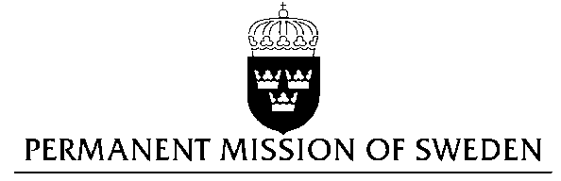
UN Human Rights Council

UPR 27th session

Statement by Sweden in the interactive dialogue on Ecuador

1 min 25 secs

Mr President,

Sweden wishes to welcome the delegation of Ecuador.

Sweden recommends the Government of Ecuador:

- To take concrete measures to promote and protect the right to freedom of opinion and expression, in accordance with what is stated in article 19 of the Universal Declaration of Human Rights.

- To ensure the prevention and effective investigation of forced disappearances and violence against women.

- To systematically collect data on violence against women, sexual violence, and trafficking.

- To ensure that it grants the right to freedom of association and the possibility for associations to carry out their work without undue restrictions.

Ecuador accepted recommendations on the freedom of expression in the second UPR cycle. Despite this, a new communications law was signed in 2013 which limits the freedom of expression and allows the government to restrict media.

Femicide was included in the criminal code in 2013. We could also witness an immediate substantial increase in reported cases of violence against women. However, since the end of 2014, we understand that there has been no updated data on violence against women.

Thank you Mr. President

