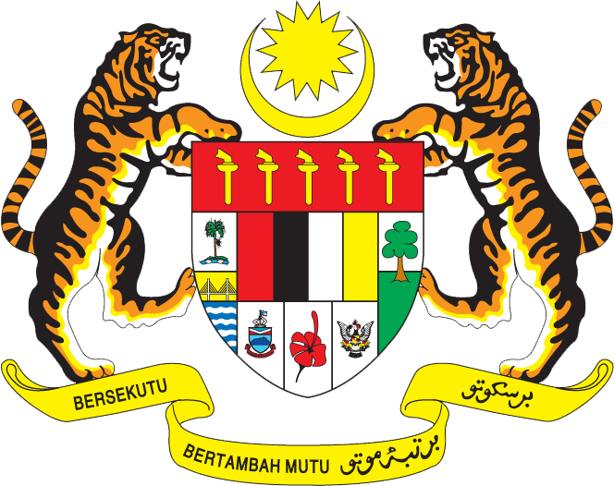

STATEMENT BY MR. SYED EDWAN ANWAR,
FIRST SECRETARY,
PERMANENT MISSION OF MALAYSIA TO THE UNITED NATIONS
27TH SESSION OF THE UNIVERSAL PERIODIC REVIEW: REVIEW OF ECUADOR
OF THE HUMAN RIGHTS COUNCIL
1 MAY 2017

Mr. President,
Malaysia thanks the delegation of Ecuador for the presentation of its national report.
2. It is clear from the report that Ecuador has achieved progress since its Second Cycle Periodic Review in 2012. Malaysia welcomes the adoption by the Government of the National Plan for Good Living 2013-2017. Malaysia also applauds the efforts made by Ecuador to encourage the participation of women at all levels of decision-making, including in the judicial and legislative branches of Government, as well as the civil service. We also take note that Ecuador has increased spending in education by 298% during the period of 2008-2016 compared to the period of 2000-2006.

3. In this context, Malaysia wishes to propose the following recommendations:

3.1. One: in efforts to tackle the problems of illiteracy, continue to promote access to quality education in rural areas, which would bring long-term benefits to women, youth and indigenous groups in rural areas;

3.2. Two: continue efforts to improve healthcare facilities, particularly in rural areas, with a focus on tackling malnutrition; and

3.3. Three: further strengthen the work of the National Councils for Equality to promote an inclusive society.

4. We wish Ecuador success in its endeavours in the promotion and protection of human rights.

I thank you, Mr. President.

GENEVA

1 May 2017

