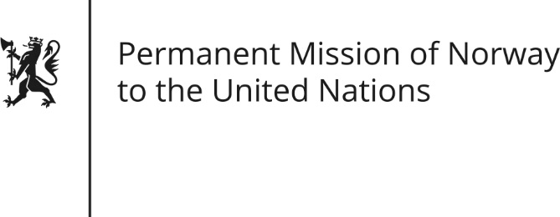

STATEMENT by Director Kjersti Roedsmoen

Universal Periodic Review 27th Session. Review of Brazil

5 May 2017

Check against delivery

(Norway thanks the Brazilian delegation for presenting its national report.)
Norway commends Brazil’s efforts to protect and promote human rights since its previous UPR. These include reduction of poverty, combating slave labor and enhancing the rights of women as well as LHBT- persons. Moreover, in spite of recent years’ political and social turbulence in Brazil, institutions and social liberties have remained intact.
However, Norway continues to be concerned about the situation of indigenous peoples. In this regard we recommend that Brazil:
- ensure that indigenous peoples are protected from threats, attacks and forced evictions;
- advance with the agenda for the indigenous peoples’ right to free, prior and informed consent.
We are also concerned about the elevated degree of violence against human rights- and environmental defenders and the level of impunity for the perpetrators involved. We therefore recommend that Brazil:
- restore functionality of the National Program for the Protection of Human Rights Defenders.

