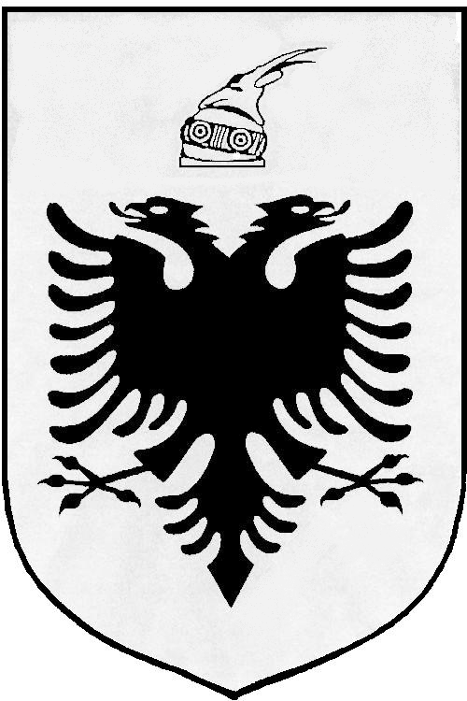
MISIONI I PËRHERSHËM I  REPUBLIKËS SË SHQIPËRISË  GJENEVË | PERMANENT MISSION OF  THE REPUBLIC OF ALBANIA  GENEVA

Universal Periodic Review

27th
Session

(1 – 12 MAY 2017)

Albania Intervention on the Third Cycle of the UPR of Brazil

Geneva, 5 May 2017

-Check against delivery-

Mr. President,

Albania would like to welcome and congratulate the Brazilian delegation on presenting their Report under the third cycle of UPR, today before the Human Rights Council.

We note with appreciation the continuing commitment of Brazil to the protection and promotion of human rights through dialogue and technical cooperation with international HR mechanisms and bodies. We commend the steps taken by government of Brazil in designing appropriate policies to fight poverty and help families in need.

While inviting the Government of Brazil to further strengthening its national efforts and human rights mechanisms, Albania would like to make the following recommendations:

- To ratify the Optional Protocols to the International Covenant on Economic, Social and Cultural Rights and to the Convention on the Rights of the Child on a communications procedure.

- To modify the antiterrorism law of 2016 and bring that in compliance with the international human rights standards.

In conclusion, Albania would like to wish to the delegation of Brazil, a very successful review.

Thank you!

