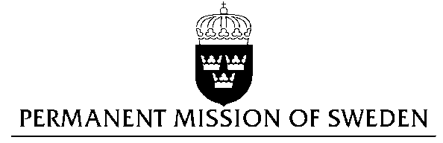
UN Human Rights Council

UPR 27th session

Statement by Sweden in the interactive dialogue on Brazil

(1 min 05 secs)

Mr President,

Sweden wishes to welcome the delegation of Brazil.

Sweden recommends the Government of Brazil:

- To take necessary measures to increase the number of gynaecologists in the Brazilian prison system.

- To take all necessary measures to effectively eliminate the incidence of child, early and forced marriage.

- To take measures to address homo- and transphobic crime, including by establishing a system for recording such crimes.

Brazilian prison facilities are severely overcrowded. The prison population is twice the size of the prison system capacity. Only 34% of the prisons have facilities for pregnant women. There are 37 gynaecologists in the Brazilian prison system, which is less than one for every 900 female inmates.

Brazil has one of the largest number of child brides in the Latin America region, and worldwide. In spite of this, the problem has not been part of policymaking agendas.

Violence against LGBTI-persons increased during the last years. In 2015, 343 persons were murdered because of their sexual orientation. As Brazil does not record crimes against LGBTI persons, we expect the problem to be significantly under-reported.

I thank you Mr. President

