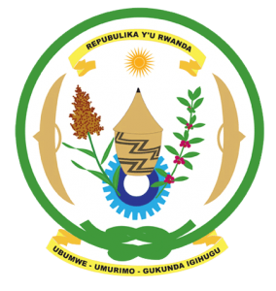
27th Session of the Universal Periodic Review Working Group
Review of Brazil
05th May 2017
Statement by Rwanda delivered by Mr. Moses Rugema
Thank you Mr. President,
- Rwanda warmly welcomes the delegation of Brazil and thanks them for the presentation of their national report and the update just provided.
- Rwanda welcomes Brazil’s commendable efforts to promote and protect human rights including through various legislative and policy measures.
- While noting the progress made in combating racial discrimination and violence against women we encourage Brazil to enhance those efforts.

Rwanda has the following recommendations. That Brazil:
- Strengthen measures to prevent and punish racism, discrimination and violence against indigenous peoples, people of African descent and violence against women and girls.
- Strengthen measures to prevent abuses by some law enforcement officials including through providing appropriate human rights training.
We wish Brazil every success in the implementation of the recommendations of this UPR.
Thank you

