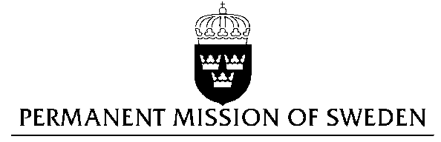
UN Human Rights Council

UPR 27th session

Statement by Sweden in the interactive dialogue on Algeria

Delivered by Minister-Counsellor Josefin Simonsson Brodén
Geneva, May 8, 2017 (speaking time 1 min 10 sec)

Mr President,

Sweden wishes to welcome the distinguished delegation and express our thanks for its presentation. Sweden would like to give the following recommendations to the Government of Algeria:

- to amend administrative and other regulations and practices in order to implement the constitutional provisions regarding freedom of the press and clarify the law on defamation and its application so as to ensure freedom of opinion and expression,
- to fully combat violence against women, to protect and support victims and to ensure that perpetrators receive penalties in accordance with the newly enacted law,
- to decriminalize same-sex sexual relations by repealing Article 339 of the Penal Code and to include LGBT persons in its legal provisions against discrimination,
- to adopt national legislation implementing the 1951 Convention relating to the Status of Refugees and its 1967 Optional Protocol, in order to institute a functioning system for the processing of refugees in accordance with international law and to grant protection to refugees determined and recognized as such by UNHCR.

Sweden commends Algeria for its constitutional guarantees for freedom of opinion and expression, freedom of the press and freedom of information, but the implementation has been inconsistent. Independent journalists and independent media outlets face increasing restrictions, not least on the basis of the excessively restrictive Law on Information.

Sweden notes that domestic and sexual violence is prevalent in Algeria. We therefore welcome that a new law came into effect in February 2016 severely sanctioning violence against women. However, these penalties are not systematically applied. The Penal Code prohibits rape without defining it and does not recognize marital rape.

Same-sex sexual relations are forbidden in Algeria according to Article 338 of the Penal Code, but homophobic attitudes in society are strong, as is overt discrimination against transgender and intersex persons. The Government must intervene against hateful propaganda and forbid harassment or threats against LGBT persons.

Although Algeria is a state party to the 1951 Convention relating to the Status of Refugees and its 1967 Optional Protocol, it still lacks national asylum legislation.

Finally, Sweden wishes the Government of Algeria a successful UPR.

Thank you, Mr President.

