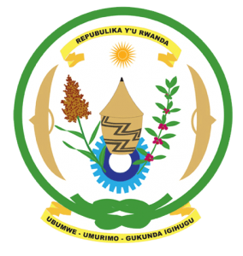
27th Session of the Universal Periodic Review Working Group
Review of the Algeria
08th May 2017
Statement by Rwanda delivered by Mr. Moses Rugema
Thank you Mr. President,
- Rwanda warmly welcomes the delegation of the Algeria and thanks them for the presentation of their national report and the update just provided
- Rwanda welcomes Algeria’s commendable efforts to promote and protect human rights, promote the rule of law and consolidate the democratic process including through the successful constitutional review.
- While noting the progress made in combating violence against women including amendments to the criminal code, we encourage Algeria to enhance those efforts by fully implementing relevant laws and eliminating any loopholes in national legislation that might undermine the protection of women’s rights.

Rwanda has the following recommendations. That Algeria:
- Withdraws its remaining reservations to the CEDAW.
- Consider ratifying the Optional Protocol to the Convention against Torture.
We wish Algeria every success in the implementation of the recommendations of this UPR.
Thank you

