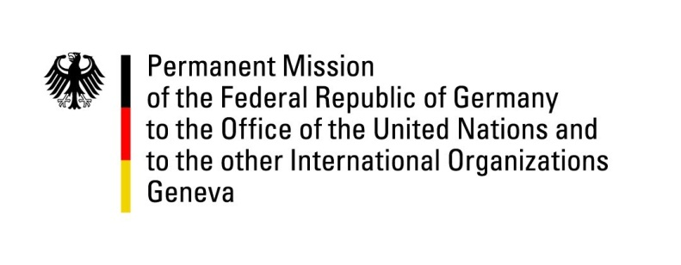

United Nations Human Rights Council
27th Session of the UPR Working Group

Geneva, 8 May 2017

---
German recommendations
to
Algeria

Mr President

Germany welcomes the delegation of Algeria to the UPR and thanks for the presentation of the report.
We positively note the constitutional reform that was enacted in March 2016 and that strengthened basic rights, in particular with regard to gender equality.
Yet, we remain concerned that there remain challenges to the human rights situation.

Germany therefore offers the following recommendations:

1. Reform the association law 12-06 of 2012 to provide a clear and unambiguous legal foundation for the work of civil society organizations, including with regard to cooperation with international partners.
2. Reform the family code to remove remaining discriminations against women.
3. Enact a law on asylum seekers and refugees to ensure that migrants enjoy a safe legal status.

Thank you Mr President

Advance questions Germany
UPR Algeria

1. Will the Government of Algeria respond positively to the requests of United Nations special procedures mandate holders, including the Special Rapporteurs on torture and freedom of assembly, to visit the country?
2. What actions has the Government of Algeria taken to improve the rights of employees to voice their interests, in particular with regard to the role and status of independent unions?
3. What measures did the Government of Algeria enact to enable and guarantee freedom of expression in print media, radio and the internet?

