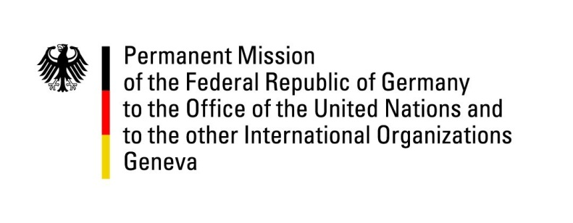

26th Session of the Universal Periodic Review

Geneva, 2. November 2016

Second Universal Periodic Review of Zimbabwe

German Statement

Mr. President,

Germany welcomes the delegation of Zimbabwe to the UPR. Germany notes with appreciation that Zimbabwe has adopted a new constitution in 2013. However, we remain concerned that many laws are not yet aligned with this new constitution and that in practice human rights are repeatedly violated by state officials and security forces.

Germany offers the following recommendations to Zimbabwe:

- As previously recommended, ratify the CAT and its optional protocol, implement its standards into national law and take immediate and concrete actions against the practice of torture by State officials.
- As previously recommended, amend existing rules for the security forces, including the Public Order and Security Act, to ensure that the rights to peaceful assembly, freedom of association and freedom of press can be exercised.
- Harmonize all laws with the Constitution of 2013 and ensure they are implemented in full accordance with human rights.
- Ensure adequate means, both financial and material, of the Human Rights Commission and the National Peace and Reconciliation Commission to enable them to fully and effectively fulfil their constitutional mandates.

Thank you, Mr. President.

Germany’s advance questions for the UPR of Zimbabwe.

1. Despite accepting the recommendations of Germany and several other countries to ratify the United Nations Convention against Torture and Other Cruel, Inhuman or Degrading Treatment or Punishment (UNCAT) the Zimbabwean Government has not yet fulfilled its obligation, which is why Germany would like to know, what challenges Zimbabwe might be facing that are causing the delay in the ratification of UNCAT and its Optional Protocol (OPCAT).
2. Numerous reports document indicate that the exercise of basic fundamental civic and political rights in Zimbabwe is restricted through legal provisions that are hostile to the right of freedom of expression as enshrined in the Constitution of Zimbabwe and under international law. Incidents in which human rights defenders, media representatives and government critics have been the target of harassment, arbitrary arrest and torture are unacceptable and corroborate concerns that freedom of speech and freedom of assembly, although being guaranteed in the Zimbabwean constitution, are being restricted systematically and intentionally. Germany would like to know what steps Zimbabwean Government is taking to safeguard and guarantee these two fundamental rights and freedoms of its citizens.
3. Zimbabwe enacted a new Constitution on 22 May 2013. In addition to the establishment of independent commissions to support democracy, the Constitution broadened and strengthened constitutionally guaranteed rights by introducing a range of economic, social and cultural rights. Following the formation of a new government, the Zimbabwean Government committed itself to align laws to the new constitution. Germany would like to know what steps the Zimbabwean Government is taking to ensure a speedy implementation of the Constitution and establishment of key constitutional offices.

