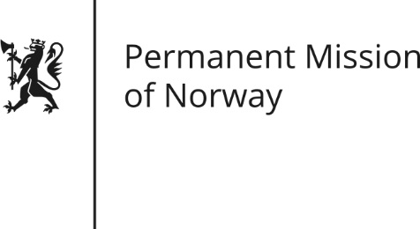

STATEMENT
Universal Periodic Review (UPR): ZIMBABWE

by Ambassador Hans Brattskar, Permanent Representative

Wednesday 2 November 2016

Check against delivery

Norway welcomes the presentation of the national report by the delegation from Zimbabwe, and takes note of the stated intention of promoting and upholding human rights for all. We recommend that the Government of Zimbabwe cooperates closely with civil society in the follow up to this UPR (Universal Periodic Review).

Norway notes with concern the high number of arrests of Human Rights Defenders and peaceful protesters, and continued restrictions on the freedom of expression in Zimbabwe. We recommend that Zimbabwe takes concrete steps to create and maintain a safe and enabling environment for human rights defenders. We further recommend that the Public Order and Security Act (POSA) and Private Voluntary Organisations Act (PVOA) are reviewed and updated to be in line with international human rights standards.

Norway recommends that Zimbabwe ensures that upcoming legislation will not limit citizens’ rights to engage in free and private exchange of information on social media. Finally, we recommend that Zimbabwe makes efforts to promote free and unbiased local media, including by removing restrictions on local radio broadcasts.

We also recommend that steps be taken to promote economic growth with a more equitable distribution of resources, to ensure social and economic rights for all. We recommend that Zimbabwe works closely with the international community in the humanitarian response to the ongoing drought and to ensure that humanitarian aid is distributed in a non-political, non-discriminatory manner.

Thank you.

