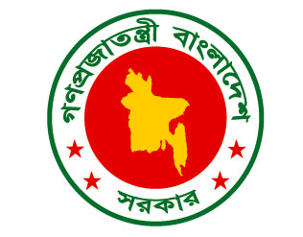

Bangladesh Statement for the
REVIEW OF ZIMBABWE
26th UPR; 2nd November 2016
Thank you Mr. Vice President

- Bangladesh welcomes the Zimbabwe Delegation and commends presentation of its National Report and continued engagement with the UPR process.

- With the adoption of its new Constitution in 2013, based on principles of rule of law and fundamental human rights, Significantly, despite many challenges, Zimbabwe has moved towards implementing recommendations made during 12th UPR Session. Steps like establishing Constitutional Court, National Prosecuting Authority, Gender Commission, National Peace and Reconciliation Commission and strengthening of Zimbabwe’s Human Rights Commission, Media Commission and Electoral Commission, economic empowerment funds for SMEs are certainly praiseworthy. We encourage Zimbabwe to sustain the momentum.

Mr. Vice President,

- We also note that challenges such as HIV/AIDS pandemics, capacity constraints, inadequate financial support, international sanctions and food insecurity as a result of climate change prevent Zimbabwe from doing more for her vulnerable population. We, therefore, believe removing international restrictions would further development and support promotion and protection of all human rights, including right to development.

- We recommend that Zimbabwe:
- Continues to strengthen its policies and measures for the empowerment of women and
- Undertakes efforts as set out in SDGs, especially those related to poverty, education, health, housing and water and sanitation

- We wish Zimbabwe well.
- I thank you.

