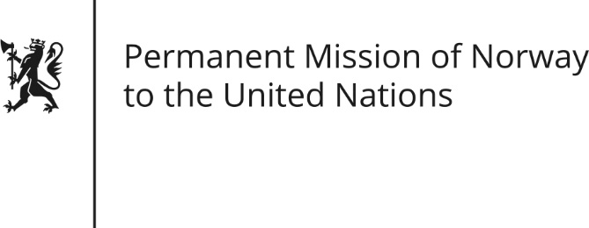

STATEMENT

Universal Periodic Review 26th Session. Review of Venezuela.

1 November 2016

We welcome the delegation of Venezuela. We are troubled by the general development of human rights conditions in Venezuela since their first UPR.
Norway is concerned with the judicial processes against members of the political opposition and imprisonment of political leaders. We reiterate our recommendation from the previous UPR to allow visits from special procedures representatives of the Human Rights Council and other relevant human rights institutions and mechanisms.
Norway is also concerned about limitations on the rights of citizens to express themselves peacefully and democratically through well-established constitutional mechanisms such as a presidential recall referendum. We recommend to channel social, political and institutional conflicts through dialogue and democratic participation, while ensuring judicial independence and the separation of powers.
We further recommend taking action to alleviate the burden on the health care system.
Finally, Norway recognizes Venezuela's constructive role in the Colombian peace process, an example that dialogue is indeed a key tool to overcome political differences and improve human rights.

