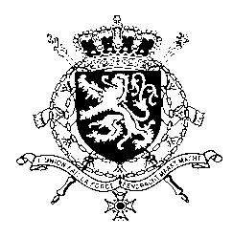
Représentation permanente de la Belgique auprès des Nations Unies et auprès des institutions spécialisées à Genève

WG UPR 26 – Venezuela (Bolivarian Republic of)
Intervention of Belgium
1st of November 2016

Mr. President,
Belgium welcomes the delegation of Venezuela and wishes to congratulate Venezuela with the adoption of a National Human Rights Plan.
The promotion and protection of women’s rights are a Belgian priority. We therefore welcome the recent reinforcement of legislation and adoption of measures regarding the protection of women. However, further progress can be achieved in the area of access to the health care system, in particular to sexual and reproductive health services. Belgium also wishes to express its concern regarding the deteriorating socio-economic situation in the country.
In this regard, we would like to formulate the following recommendations:
R1. To take immediate action to ensure essential levels of food supply and consumption in the population, protecting the most vulnerable groups from hunger and nutritional problems which may cause irreversible damage to health.

R2. To adopt a comprehensive program on sexual health and reproductive rights based on human rights and WHO standards and to allocate sufficient financial and human resources for its implementation.
Furthermore, the lack of a safe and enabling environment in which it is possible to defend human rights without fear for reprisals or intimidations remains an area of concern. We therefore recommend:
R3. To explicitly and publicly recognize the legitimacy of the work of human rights defenders, including by making public statements recognizing their contribution to the promotion and protection of human rights and the rule of law.
I thank you, Mr. President

