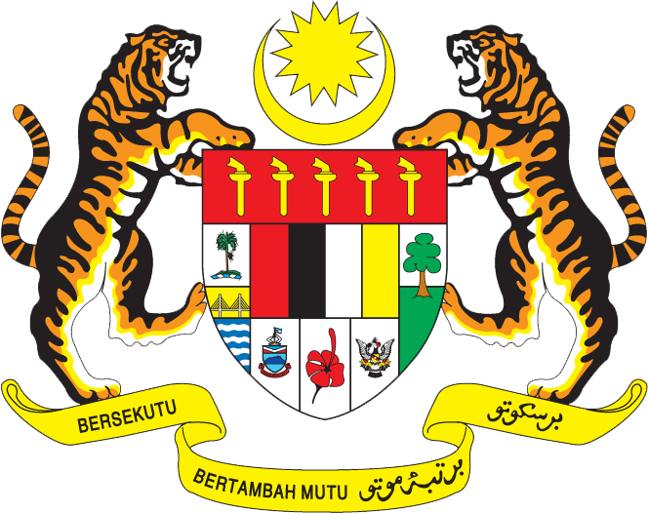

Statement by Ms. Syuhada Adnan, Second Secretary
Permanent Mission of Malaysia to the United Nations Office and Other International Organizations in Geneva
Review of the Bolivarian Republic of Venezuela
26th Session of the UPR Working Group of the Human Rights Council
31 October - 9 November 2016

Thank you Mr. President,

Malaysia welcomes the constructive approach taken by Venezuela in the preparation of its second UPR and thanks the delegation of Venezuela for the presentation of the report.

- Malaysia acknowledges the efforts made by the Government of Venezuela to overcoming the challenging socioeconomic situation that have impacted the capacity of the country to achieve its desired progress in the promotion and protection of human rights. Despite these challenges, Venezuela has continued to advance its commitments, including the mainstreaming of a gender perspective, empowering of women, improving the healthcare system, and ensuring education for persons with disabilities.

- In the spirit of constructive engagement, my delegation would like to propose the following three recommendations for the consideration of Venezuela:

  - One: Improving legislation, policies and guidelines regarding human rights education and training for the legal and justice system;

  - Two: continue to provide resources and develop strategies for youth development, including in achieving a greater percentage of completion of higher education for all, the retention of pregnant girls and adolescent mothers in schools, the provision of technical and vocational skills, and the expansion of social and economic opportunities for youth; and

  - Three: combat violence against women through coordinated and comprehensive preventative measures, and ensuring access to justice and remedy for victims.
.
I thank you, Mr. President.

GENEVA
1 November 2016

