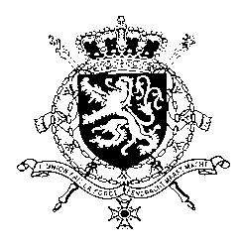
Représentation permanente de la Belgique auprès des Nations Unies et auprès des institutions spécialisées à Genève

WG UPR – Uganda
Belgian Intervention
3rd of November 2016

Mr. President,

Belgium welcomes the delegation of Uganda and wishes it every success in the exercise of its second Universal Periodic Review.

We acknowledge the progress made by Uganda in implementing the recommendations accepted during its first UPR, in particular the adoption of a National Plan on human rights and the measures taken concerning the prevention and prohibition of torture.

However, some recommendations accepted by Uganda in the previous UPR were not implemented and on certain issues there is still room for progress, particularly regarding the death penalty and the juvenile justice system.

In this regard, Belgium wishes to formulate the following recommendations:

R1. To consider ratifying the Second Optional Protocol to the International Covenant on Civil and Political Rights, aiming at abolition of the death penalty.

R2. To strengthen the juvenile justice system, in particular by ensuring the designation of specialized courts and judges, which would apply procedures that take into account the specific needs of children.

R3. To increase access to sexual and reproductive health services by raising the health budget to 15% in line with the Abuja declaration and by creating a health insurance scheme for the poor.

I thank you, Mr. President

