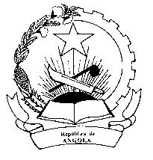
Mission Permanente
République de l'Angola
Genève

STATEMENT OF THE REPUBLIC OF ANGOLA
ON THE ADOPTION OF UGANDA REPORT ON UPR SECOND CYCLE

Mr. President,
The Republic of Angola would like to congratulate the delegation of Uganda for the presentation of the report on the second cycle of the UPR.
We comend Uganda for the achievement on the general election held in February this year, in a free, fair and transparent atmosphere, whose result refleted the will of the Ugandan people.
We welcome the measures taken by the Uganda in the economic and social framework, in particular the adoption of the National Action Plan for Human Rights and the National Policy for Agriculture, which in our view constitutes important tools in the promotion and protection of human rights, as well as in the reduction on inequalities and poverty.
Angola notes that despite the efforts made, Uganda faces many challenges in the legislative sector, the adequacy of some national laws to international Treaties, access to education for the vulnerable sector of the population, reducing child maternal mortality, as wel as birth registration.
Angola woul like to recommend Uganda :
- To strength the implementation of the National Action Plan for Human Rights;

- To implement legal provisions for ¨better protection of person with disability;

- To promote the participation of women in the process of national development;

- To adopt measures to reduce the number of children without birth registration;

Finally, Angola wishes the delegation of Uganda success in the second cycle of the Universal Periodic Review.

Thank you

