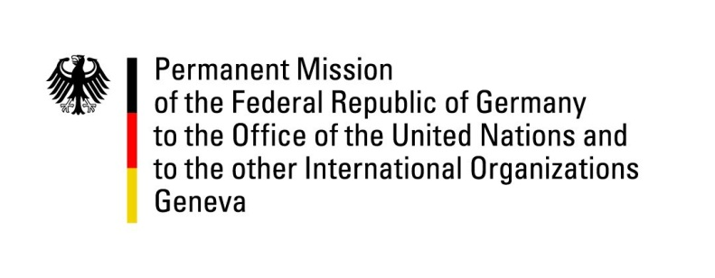

26th Session of the Universal Periodic Review

Geneva, 3 November 2016

Second Universal Periodic Review of Uganda

German Statement

Mr. President,

Germany welcomes Uganda to the UPR. We take note with appreciation of the progress made by Uganda for example by adopting the Prevention and Prohibition of Torture Act.
However, we are concerned by continuing cases of torture. We condemn discrimination of women and infringements of the right to freedom of peaceful assembly, mostly targeted at the political opposition but also at other groups such as members of the LGBTI community.

Germany therefore offers the following recommendations:

- Ratify the Optional Protocol to the Convention against Torture and other Cruel, Inhuman or degrading Treatment or Punishment, promote strict adherence to the prohibition of torture, inhuman or degrading treatment or punishment and prosecute violations thereof.
- Amend the Public Order Management Act, 2013, and the Non-Governmental Organisations Act, 2016, to ensure free assembly and association in line with international human rights standards.
- Swiftly enact the Marriage and Divorce Bill of 2009 to end discrimination of women in family law and enact a new Succession Act promoting equal inheritance rights for both women and men.
- Fully implement the School Health Policies and the Adolescent Health Policy to provide reproductive health education for adolescents and prevent teenager pregnancy.

I thank you, Mr. President.

Questions Submitted in Advance by Germany:

- What steps is Uganda taking to prevent tortures, prosecute perpetrators and offer reparation to victims?
- Will Uganda amend the Non-Governmental Organisations Act, 2016, to ensure the right to freedom of association is guaranteed by especially removing new criminal provisions for legitimate civil society work?
- Will Uganda amend the Public Order Management Act, 2013, to fully guarantee the freedom of assembly?
- What steps is Uganda undertaking to pass the Marriage and Divorce Bill, 2009?
- What steps is Uganda undertaking to provide reproductive health education and to prevent teenage pregnancies?

