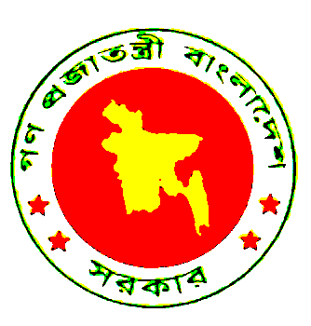
Statement of the People’s Republic of Bangladesh
UPR of Togo
31 October 2016

Thank you Mr. President.

Bangladesh delegation welcomes the delegation of Togo and its presentation of the national report. We also appreciate the efforts in preparing the national report.

Despite significant resource constraints, the Togolese Govt.’s sincere effort to give effect to all of the recommendations accepted in the first cycle review is laudable. We commend several initiatives they undertook, including the harmonization of national legislation with international instruments ratified, the adoption of policies, national and sectoral programmes and the ratification of human rights instruments. To our mind particularly stand out Togo’s initiatives with regard to reducing discrimination against women through reflections of CEDAW convention in the criminal codes, as well as through recruitment policies and awareness building communication strategies.

Mr. President, in the context of development challenges faced by Togo, we believe that “The Accelerated Growth and Employment Creation Strategy for 2013-2017” is very appropriate to improve the human rights situation in Togo by combating poverty. We are happy to note positive effect such as increase in GDP growth, income generating activities, significant increase in food production, access to safe drinking water, substantial decrease in the number of undernourished people. All these indeed would help create environment for ensuring full enjoyment of human rights across sectors in Togo.

Mr. President, the National report has identified a number of areas for international cooperation and technical assistance to overcome constraints faced by Togo. The international community should, therefore, come forward to help implement the commitments made by Togo through UPR.

I thank you.

