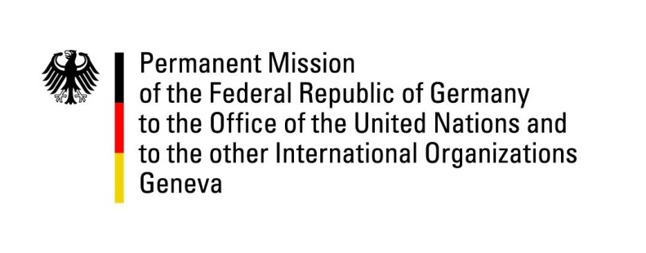

United Nations Human Rights Council
26th Session of the UPR Working Group

Geneva, 31 October 2016
---
German recommendations
to the
Syrian Arab Republic

Thank you, Mr. President.
While we are talking here in Geneva, in this very minute, the gravest violations of human rights and of international humanitarian law are ongoing in Syria.
This is why it feels very awkward to hold a “standard UPR session” on Syria.
Germany still would like to make the following four very basic recommendations:

- Immediately grant full and unconditional humanitarian access for the United Nations to the entire country, especially to the territories under siege by Syrian government forces.

- End all indiscriminate bombings of residential areas, hospitals and all other civilian targets with immediate effect.

- End all practices of arbitrary abduction, torture and murder in detention facilities. All persons unjustifiably detained must be released immediately; all others must be treated according to international standards. Full international monitoring must be permitted.

- Grant full access to the Independent International Commission of Inquiry on the Syrian Arab Republic to allow the Commission to undertake investigations inside the country and thus to enable it to fulfil its mandate to investigate all alleged violations of international human rights law since March 2011 in the Syrian Arab Republic.

I thank you, Mr. President.

Questions Submitted in Advance by Germany:

- The Syrian Arab Army and its allies impose an iron siege on 15 distinct territories in Syria, affecting more than 700.000 Syrians. Thereby the forces of the Syrian government intentionally and completely block (almost) all humanitarian aid and medical relieve for the Syrian citizens living in the respective territories, exposing these civilians to starvation, hardship and – eventually – death. What measures is Syria taking to ensure that the very basic human needs of the citizens living in the 15 territories classified by the UN as “sieged by the Syrian government” are effectively and completely addressed? What measures is Syria taking to immediately grant the UN humanitarian agencies full and unconditional humanitarian access to these 15 territories?

- Numerous reports document that the Syrian armed forces, systematically and intentionally target civilian (especially: medical) infrastructure and residential areas with heavy weapons. These incidents occur often in besieged territories, but are not limited to them. Which measures is Syria taking to prevent Syrian government forces from bombing civilian targets in Syria? Which procedures do the Syrian government forces apply to prevent civilian casualties when massively using imprecise and rudimentary weapons like artillery or barrel bombs in densely populated urban neighborhoods like Eastern Aleppo?

- Treaty bodies and human rights organizations have repeatedly reported on massive and systematic detention without trial, of torture and murder in official and secret Syrian detention facilities. According to the reports, the victims are often women and minors, whereas International organizations (UN, ICRC) are completely denied access to these facilities. What steps is Syria taking to stop torture and murder in its facilities? What steps is Syria taking in order to stop the massive detention of people without trial? What steps is Syria taking to grant international agencies full access to all detention facilities?

