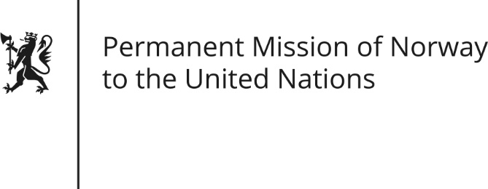

STATEMENT

Universal Periodic Review 26th Session. Review of Syrian Arab Republic.

31 October 2016

President,
Norway welcomes the Syrian delegation.
We are extremely concerned about the many reports, of systematic and gross violations of international humanitarian law and human rights law by the authorities throughout the Syrian Arab Republic.
Norway recommends:
1. An immediate cessation of all aerial bombardments over Aleppo.
2. That the Syrian government provide immediate, full, unhindered and sustained humanitarian access to the country.
3. An immediate end to all acts of torture and to stop the arrests of human rights defenders, journalists and political dissidents.
According to reports, the government forces continue to carry out brutal attacks and aerial bombardments against civilians, including medical facilities and personnel. Lengthy sieges of towns, trapping over 800 000 civilians have deprived people their basic needs. There are also continuous reports of arbitrary arrests and continued detention of thousands of individuals. Human rights defenders and journalists are particularly targeted. Reports also tell us thousands die in custody following torture. Anyone responsible for such acts must be held accountable. Norway’s recommendations from Syria’s UPR in 2011 also still stand. None have been fulfilled.
Gross violations and abuses of human rights occur throughout the country by several parties to the conflict. We strongly condemn terrorist acts and violence committed by ISIL and other terrorist organizations. We urge all parties to respect international law, including humanitarian law and human rights.
Thank you.

