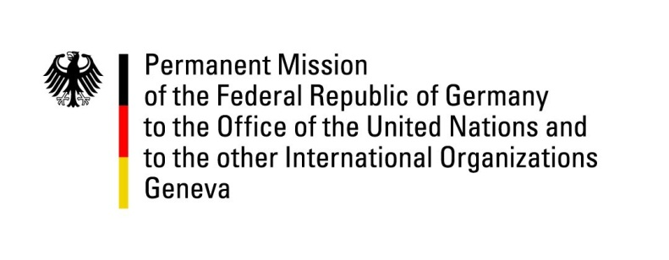

26th Session of the Universal Periodic Review

Geneva, 4 November 2016

Universal Periodic Review of the Republic of Moldova

German Statement

Mr. President,
Germany welcomes the delegation of Moldova to the UPR. Germany appreciates the progress Moldova has made in preventing torture and in bringing perpetrators to justice. Yet, some shortcomings remain and the justice sector has not yet been fully aligned with international standards. Here and in other areas, it is not only the legal framework but effective implementation mechanisms that matter. The government should make more efforts in adopting an OSCE HCNM-compliant strategy on national minorities soon.

Germany offers the following recommendations to Moldova:
- Ensure that all complaints regarding acts of torture and ill-treatment receive a prompt, impartial and effective investigation in accordance with the Istanbul Protocol and ensure that, in conformity with CAT, any statement made as a result of torture shall not be invoked as evidence in any proceedings.
- Fully implement the Justice Sector Reform Strategy to increase judicial independence and effectiveness.
- Adopt comprehensive national legislation such as the new Broadcasting Code in order to ensure media pluralism and protect independent media.
- Adopt a HCNM-compliant strategy on national minorities as soon as possible, in order to clearly affirm Moldavas commitment to national minority rights.
- Improve the operational and financial performance of water supply enterprises to increase water safety and quality.

I thank you, Mr. President.
Questions Submitted in Advance by Germany:

- What steps does Moldova plan to take to fully eliminate torture and ill-treatment?
- How does the government ensure to respect the rights of female detainees?
- What steps are planned to finalize the implementation of the Justice Sector Reform Strategy and why are court hearings in many high-profile cases declared as “non-public”, i. e. without access for the public, on a regular basis?
- What concrete amendments does the government propose to ensure the constitutionality of law No. 52 (Ombudsman)?
- When does Moldova expect to adopt the new Broadcasting Code?
- What steps does the government plan to take to provide all citizens with access to safe drinking water and to safe sanitary facilities?
- What is the timeline regarding the adoption of the strategy on national minorities and can the government ensure that an OSCE HCNM-compliant strategy will be adopted by the end of this year? Why has the strategy not been adopted already?

